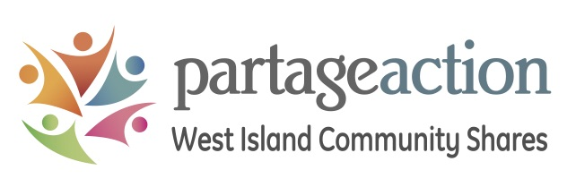
NEW GRANT APPLICATION FORM (Step 1)
ALL DOCUMENTS MUST BE SUBMITTED ELECTRONICALLY BY THE DEADLINE TO: danielle@partageaction.ca
IMPORTANT NOTE: We will follow a two-step application process for new community organisations who have never received funding from Community Shares.
Step 1: Fill out the table below, then provide a brief description of your project or organisation, expected outcomes, and the needs it meets in the West Island.
Step 2: If your organisation or project is retained for further analysis, we will ask you to fill out a full grant submission. You can expect to receive an answer towards the end of November.
West Island Community Shares is a non-profit organisation dedicated to building a strong, resilient, peaceful and healthy community. We do this by raising funds for local community organisations with the help and support of caring citizens, generous business owners and corporate partners. Last year, Community Shares gave back $1.3M to more than 40 local community organisations. Show us how your organisation will provide crucial services to West Islanders in need.
Organization name:
Year the organization was founded:
Executive Director or person in charge:
Telephone number:
Address (main office):
City:
Postal code:
Email address:
Charitable organization’s Registration Number (Canadian Revenue Agency CRA #):
Total budget for the last fiscal year:
Total expenses for the last fiscal year:
Total number of people who used your services last year; percentage of West Island residents
Please state your other sources of funding
(if any):

This space is for you! Tell us about your organisation. Brief history. What are your services? How many people turn for help every year? Are you able to meet the demand or do you have a waitlist? Who are your main funders? Do you collaborate with other community organisations? If so, how do you work together? Etc. (2-page max!)

