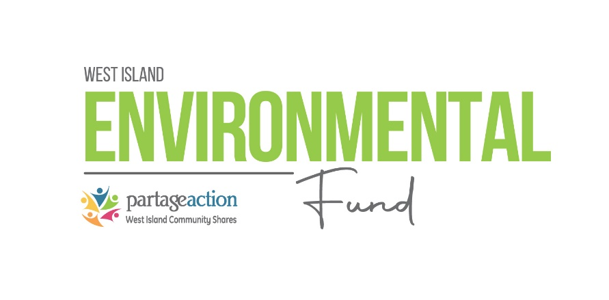
Environment Fund Grant Application Form
ALL DOCUMENTS MUST BE SUBMITTED ELECTRONICALLY TO: isabelle@partageaction.ca

Step 1: Fill out the table below and provide a brief description of your project, the expected outcomes, and what makes it an environmental initiative for the West Island.
Step 2: If your project is retained by the environmental fund committee, you will be contacted by our team for further instructions.
IMPORTANT NOTICE: This fund will not support any environmental advocacy or political activities or projects.
Organization or Project name:
Project Lead:
Telephone number:
Address:
City:
Postal code:
Email address:
Estimated project budget:
Estimated project expenses:
Estimated participants in project:
Please state your other sources of funding
(if any):

Give us a brief overview of your project: What is involved? Who are the participants? How will you implement this project? What are the objectives? What are they expected outcomes? Do you have any collaborators? What makes this project a West Island ‘Green’ initiative? Please include any supporting documentation (posters, budgets, proposals etc) (2-page max!)

