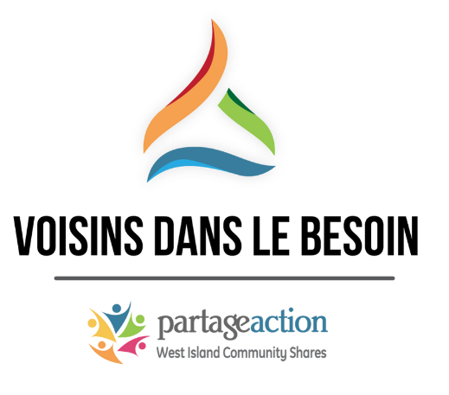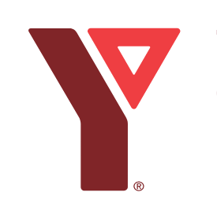

ASSISTANCE FUND - NEIGHBOR IN NEED
Friday, June 25, 2021
Following the devastating major fire, at the apartment complex at 35 and 37 Brunswick Boulevard in Dollard-des-Ormeaux, which occurred on June 5, 2021, a special assistance fund has been set up for those affected and removed from their homes because of this disaster. All donations will go directly to affected families and/or community organizations that provide services to them. The closing date for the collection of donations was June 20, 2021 from which a total of $29,500 was collected.

To establish your eligibility to receive a share of the donations, please complete all fields of the following form and return it to meagan.somerville@ymcaquebec.org no later than July 12, 2021.
Address at time of loss: __________________________________________________________
Apartment Number: ____________
Number of people living in the apartment: _______
Name of each tenant and age:
1 – First Name : _____________________________Last Name : ___________________________
Age: ______________ Phone # (if needed): ____________________
*Primary person who will receive the cheque.
2 – First name:______________________________ Last name: __________________________
Age: ______________
3 – First name: ______________________________ Last name: _________________________
Age: ______________

4 – First name: ________________________________ Last name: ________________________
Age: ______________
5 – First name: ________________________________ Last name: ________________________
Age: ______________
6 – First name: _________________________________ Last name: _______________________
Age: ______________

Proof of residency for each of the named tenants is required. For adults, a Hydro bill, driver's license, lease agreement, etc. would be suitable. For school age children, a school report card with address would be appropriate. For young children, a birth certificate or daycare bill would be appropriate.
*The amount allocated will be sent by cheque issued to the name of the person registered at #1.
The cheque must be deposited within the next 6 months, otherwise the cheque will expire and no other cheque will be sent.

Please indicate the new complete address where the cheque must be sent:
______________________________________________________________________________

Note: The YMCA offers you its assistance to complete the documents on site at 230 Brunswick Boulevard in Pointe-Claire (H9R 5N5). Call 514-630-9622, ext. 5202 to schedule an appointment. Please have your proof of residency with you.

