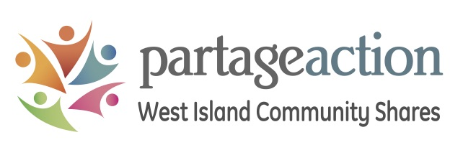
NEW GRANT APPLICATION FORM
DEADLINE FOR SUBMISSION DECEMBER 1, 2022
ALL DOCUMENTS MUST BE SUBMITTED ELECTRONICALLY BY THE DEADLINE TO: danielle@partageaction.ca
IMPORTANT NOTE: We will follow a two-step application process for new community organisations who have never received funding from Community Shares.
Step 1: Fill out the table below, then provide a brief description of your project or organisation, and the needs it meets in the West Island.
Step 2: If your organisation or project is retained for further analysis, we will contact you for more information and follow-up documentation.

Organization name:
Year the organization was founded:
Executive Director or person in charge:
Telephone number:
Address (main office):
City:
Postal code:
Email address:
Charitable organization’s Registration Number (Canadian Revenue Agency CRA #):
Total budget for the last fiscal year:
Total expenses for the last fiscal year:
Total number of people who used your services last year; percentage of West Island residents
Please state your top 5 sources of funding
(if applicable):

Tell us about your organisation: What is your mission? What are your programs and services? Do you have any special projects? How many people turn for help every year? Do you have a waitlist? What would you use the funding for? Do you collaborate with other community organisations? Etc. (2-page max!)

